**Catalog**

Introduction 1

Purpose and audience 1

Platform overview 2

What is RflySimSaT? 2

RflySimSaT platform architecture 2

Platform core components 3

key development stages 5

Features 5

Advantages 6

Supported hardware and operating systems 7

RflySim supporting learning materials 8

Installation and configuration 8

Platform installation and configuration 8

Use the platform 12

General development process introduction 12

Development preparation case (multi-rotor as an example) 14

Automated test case (quadcopter) 42

Other cases 49

## Introduction

### Purpose and audience

The primary purpose of this user manual is to provide researchers, developers, and practitioners in the field of unmanned aerial vehicles (UAVs) with a detailed operational guide and reference for the RflySimSaT UAV Safety Assessment Platform. The operational guidelines aim to assist users in comprehensively understanding and utilizing the platform for assessing the safety of UAVs, mitigating risks, and ensuring system stability and performance. Specifically, the objectives of this user manual are:：

* **Comprehensive Feature Description:** Help users become familiar with the various modules, functionalities, and features of the RflySimSaT platform, enabling them to leverage these tools effectively for safety assessments.；
* **Detailed Operating Instructions:** Provide users with step-by-step operational procedures to ensure they can correctly configure, run, and analyze the safety of UAVs；
* **Diverse Analysis Methods:** Introduce users to how the platform can be used for analyzing UAV performance in different scenarios, including fault simulation, risk assessment, and computation of safety metrics.

Target Audience

The intended audience for this user manual includes the following categories of individuals:

* **UAV Researchers:** UAV manufacturers and software developers aiming to ensure the excellent performance of their products. They need to assess the safety, performance, and stability of UAVs. The manual offers effective tools and methods to meet their research needs；
* **Industry Practitioners:** Professionals in various industries where UAVs are widely utilized, such as agriculture, logistics, and aviation. Industry practitioners need to understand how to assess the safety of UAVs to ensure their safety in daily operations；
* **Educational Institutions:** Universities, research institutions, and training centers that may use the RflySimSaT platform for teaching UAV-related courses. The manual provides rich cases and operational examples suitable for teaching and research；
* **Government Regulatory Authorities:** Government agencies require an understanding of UAV performance and safety to formulate appropriate regulations and policies. The manual can help them grasp methods and tools for UAV safety assessment.

This user manual is designed to follow a style typical of usage manuals, providing clear and concise instructions for effective utilization of the RflySimSaT UAV Safety Assessment Platform.

## Platform overview

### What is RflySimSaT?

RflySimSaT is a platform dedicated to the safety testing and evaluation of unmanned aerial vehicle (UAV) autopilot systems. Built upon our previously released high-fidelity Hardware-in-the-Loop (HIL) simulation platform, RflySim (<https://rflysim.com/docs/#/en/>),RflySimSaT inherits the key characteristics of RflySim. It utilizes MATLAB/Simulink as the core programming platform for UAV system model design and algorithm development, with Python serving as the tool for top-level vision and cluster algorithm development. Beyond MATLAB/Simulink and Python, the RflySimSaT platform incorporates various open-source software and tools, including those specifically designed for this purpose. On this foundation, RflySimSaT introduces a fault injection interface, integrates open-source database software, and supports the importation of UAV test cases into the platform, enabling end-to-end fault injection and data analysis.

### RflySimSaT platform architecture

As shown in Figure 1, the overall framework of RflySimSaT comprises key modules, including the lower-level controller, motion simulation model, 3D simulation model, top-level controller for vision clusters, and others. This forms a closed-loop simulation and development system that is compatible with both hardware-in-the-loop (HIL) simulation and software-in-the-loop (SIL) simulation. RflySimSaT is a comprehensive, flexible, and efficient solution designed for unmanned aerial vehicle (UAV) systems. By combining MATLAB/Simulink, Unreal Engine, and Python tools, it provides multi-level system development support and ensures the safety of UAV systems throughout their lifecycle. With rich virtual testing scenarios, software-hardware compatibility, and automated testing capabilities, this platform can meet diverse user requirements, providing all-around assurance for the safety of UAV systems.



Figure 1 Overall architecture of RflySimSaT platform

### Platform core components

As shown in Figure 1, the platform supports programming languages such as MATLAB/Simulink, Python, C/C++, etc. The core software of the platform includes CopterSim, RflySim3D, SIL/HIL one-click start simulation script, etc.

**（1）CopterSim:** CopterSim is the core component of the RflySim platform, responsible for running real-time simulation models, interacting with controllers, and serving as the data relay center. The autopilot connects to CopterSim through either a serial port (Hardware-in-the-Loop - HITL) or network TCP/UDP (Software-in-the-Loop - SITL) using MAVLink for data transmission, simulating outdoor flight scenarios. CopterSim receives motor control signals from the "lower-level controller" via an external interface, drives the model forward in real-time at a periodic rate (1000 Hz), transmits simulated sensor data (acceleration, GPS, magnetometer, etc.) back to the "lower-level controller" for normal operation (masking hardware sensor data, using simulated data as a substitute), and sends simulation status data to the "3D simulation model" for visualization of the unmanned vehicle's motion.

The unmanned aerial vehicle's motion simulation is primarily developed in the MATLAB/Simulink environment as a high-precision six-degree-of-freedom kinematics and dynamics vehicle model. This model is then converted into C/C++ code through automatic code generation, compiled into a DLL dynamic-link library model file, and imported into the CopterSim simulation software for real-time simulation. By importing the model as a dynamic-link library, users can develop their own unmanned vehicle models and integrate them into the entire simulation system, enabling software/hardware-in-the-loop simulation for specific vehicles.

In the MATLAB/Simulink environment, users can also establish fault models for the vehicle in the "Motion Simulation Model," trigger them at appropriate times through external input interfaces, and thus achieve fault injection and automated testing functions.

**（2）Autopilot (Lower-level Controller):** The "lower-level controller" module, as shown in Figure 1, provides two paths for the autopilot to participate in simulation: hardware-in-the-loop (HITL) or software-in-the-loop (SITL). In HITL, PX4 control software runs on hardware boards like Pixhawk, forming a complete hardware-in-the-loop closed-loop by connecting to the "motion simulation model" on the PC via a serial port. In SITL, PX4 control software runs in a virtual compilation environment on a PC (without the need for real controller hardware) and connects to the "motion simulation model" running on the same PC via internal networking, forming a complete software-in-the-loop closed-loop.

It is important to note that both HITL and SITL involve running the complete PX4 control software system; hence, the control effect is nearly identical. HITL is recommended in the early stages of algorithm development for better real-time performance, but it incurs higher hardware costs. SITL is recommended primarily during initial algorithm development, with a transition to HITL when algorithm migration to actual hardware is required.

**（3）RflySim3D/RflySimUE5 (3D Simulation Model):** RflySim3D/RflySimUE5 is a highly realistic simulation software developed based on the Unreal Engine, inheriting various advantages of the Unreal Engine. It communicates with other platform software via UDP, achieving high-fidelity simulation of unmanned systems. Moreover, it transmits visual image data to software such as QGroundControl, MATLAB, Python, etc., through methods like screen capture and shared memory for visual algorithm verification simulation. RflySim3D/RflySimUE5 mainly performs functions such as visual effect display (3D visualization, VR display, special effects display, perspective switching, etc.), physical collision detection (including collisions between the vehicle and ground objects, collisions between vehicles, etc.), network communication performance testing (including obstructions such as buildings and trees between vehicles, interference radiation angle ranges, etc.), loading of global satellite images for large-scale scenes, and generation of visual sensor data (RGB images, depth maps, laser point clouds, etc.).

**（4）QGroundControl (Ground Station):** The ground station is a critical component of the unmanned aircraft application control system. Operators can control the drone by operating the ground station using a mouse, touchscreen, or remote control, setting waypoints and planning routes on the ground station. This allows the drone to fly along the preset path and complete waypoint tasks during flight, including taking photos, performing aircraft maneuvers, recording videos, etc. Currently, the mainstream open-source ground stations are QGroundControl and MissionPlanner, with QGroundControl being a modern, user-friendly, open-source ground station designed for the Pixhawk4 flight control system. It is built using the QT editor with C++ for core code and QML with C++ for interface files. QGroundControl supports source code modification and secondary development of functions, making it suitable for both research experiments and customization/modification of ground station functions. QGroundControl offers advantages such as open-source nature, ease of use, multi-platform support (Windows, Linux, MacOS, etc.), and a modular architecture. The modular architecture of QGroundControl allows developers to easily add and extend new features without affecting existing functionality and performance. In summary, QGroundControl is a modern, user-friendly, open-source, and highly customizable ground station software with significant advantages in multi-platform support, multi-language support, and modular architecture. For more learning materials and tutorials, please visit <https://docs.qgroundcontrol.com/master/en/index.html>。

### Key development stages

* MATLAB/Simulink Integration: Serving as the core programming platform, MATLAB/Simulink provides robust capabilities for system modeling and algorithm development. Users can easily construct unmanned aerial vehicle (UAV) system models and engage in system design and algorithm development using Simulink.
* Python Integration: Python plays a crucial role in the development of top-level vision and cluster algorithms. Its flexibility and powerful ecosystem enable users to rapidly develop and integrate advanced vision and cluster algorithms efficiently, facilitating automated testing on the platform.
* Unreal Engine Integration: Combined with the Unreal Engine, the platform offers rich three-dimensional testing scenarios, covering diverse environmental conditions to ensure comprehensive testing of UAV systems.
* Software and Hardware Adaptation: The platform supports the adaptation of software developed for vehicle models to different autopilot hardware, ensuring reliable and seamless transitions at various stages.
* Safety Testing Case Division: According to airworthiness standards and requirements, the platform can categorize safety testing cases, aiding users in a comprehensive assessment of the safety of UAV systems.
* Automated Testing and Evaluation: The platform features automated testing and evaluation capabilities. By loading test cases from a library, it efficiently conducts safety assessments of unmanned aerial vehicles.

### Features

* Comprehensive UAV System Safety Solutions.
* Integration of MATLAB/Simulink and Unreal Engine for Multilevel System Development.
* Rich Virtual Testing Scenarios Ensuring Comprehensive and Realistic Testing.
* Introduces specifically designed software and tools, tailored for UAV safety testing and evaluation.
* Supports a complete workflow, enabling users to inject faults and analyze resulting data comprehensively.
* Software and Hardware Adaptation Supporting Smooth Transitions at Different Stages.
* Test Case Division Based on Airworthiness Standards and Requirements Ensuring Comprehensive and Compliance Testing.
* Automated Testing and Evaluation Functionality to Enhance Testing Efficiency.

### Advantages

**RflySimSaT features the following:**

* **Affordability:** Considering factors such as the scale, functionality, and hardware of the testing platform, actual experiments with UAVs are often costly, inefficient, hazardous, and subject to strict regulations. From both economic and technical perspectives, RflySimSaT provides a highly reliable and affordable safety testing platform. It can simulate normal and fault scenarios of flight experiments, meeting basic safety development and testing requirements, making UAV development and testing more accessible.
* **Scalability:** Inheriting the user-friendly advantages of RflySim, RflySimSaT is easy for non-technical personnel to use, supporting one-click installation, one-click firmware deployment, one-click hardware-in-the-loop simulation, and rapid actual flights. Additionally, RflySimSaT supports various UAV brands and models. It only requires connecting different autopilots to the simulation computer and configuring them in the ground control station. Moreover, RflySimSaT integrates algorithm evaluation interfaces, supporting users in quickly deploying their own health assessment, fault diagnosis, fault-tolerant control, and other algorithm modules. Users can utilize the platform-generated data to validate the safety and reliability of algorithms.
* **Multi-Fault Type Testing:** The RflySimSaT platform adopts a distributed fault injection architecture, establishing model fault, communication fault, and environmental fault interfaces. The model fault module, implemented through Simulink fault models and standardized external trigger interfaces, can simulate faults in IMUs, power units, wind, and other types of sensors. The communication fault module, by forwarding all communication links through a unified interface, can simulate faults like delays and packet loss. The environmental fault module, using the three-dimensional engine to dynamically generate obstacles or other objects of specified dimensions and sizes, can simulate various safety testing scenarios in real environments.
* **Multi-Task Scenario Testing:** RflySimSaT, based on the Unreal Engine, constructs three-dimensional scenes with highly realistic real-time rendering effects. It inherits the characteristics of RflySim in supporting multiple aircraft models and cluster simulations, meeting security and reliability testing needs for multi-agent swarm formation and intelligent decision-making, distributed networking, swarm cooperative exploration, multi-scenario cooperative attack, and defense, among others. RflySimSaT provides some basic test scenarios, and users can also design their own scenes according to their needs, catering to various testing requirements.
* **Automation:** RflySimSaT supports the importation of standardized test cases from a database, enabling automated traversal of test cases, automatic collection of flight data, and automated safety and reliability assessments, thereby enhancing the efficiency of development and testing.

### Supported hardware and operating systems

The RflySim platform provides a comprehensive set of supporting hardware systems, including quadcopter drones, flight controllers, and remote controllers. These components are all compatible with the platform, enabling software and hardware-in-the-loop simulation experiments in RflySim. The generated firmware facilitates the real-world flight of unmanned aerial vehicles.

Supported aircraft include the Feisi X150, Feisi X200, Feisi X450, among other quadcopter drones. The Feisi X150 is a newly designed miniature quadcopter for indoor cluster control research, featuring a symmetrical motor axis distance of 150mm, a fully protected structure, and a carbon-fiber 3D-printed lightweight body with high strength. It employs laser altitude holding and optical flow positioning, providing an integrated solution to enhance efficiency in indoor cluster research. The Feisi X200 is a small indoor intelligent drone with a symmetrical motor axis distance of 200mm, a full carbon fiber protective body design, and downward-facing propeller installation. It uses internal laser altitude holding and optical flow positioning, suitable for indoor drone cluster cooperative formation applications, with distributed cluster drone cooperative control capabilities. The Feisi X450 is a professional outdoor small intelligent quadcopter with a symmetrical motor axis distance of 450mm and a modular design. Equipped with an onboard computer and functional modules like depth cameras and LiDAR, it forms a complete outdoor intelligent aerial vehicle. Its outstanding performance can handle complex outdoor flight environments, making it an intelligent aerial research platform for outdoor cluster formation algorithm development, SLAM navigation, and other research areas.

Supported flight controllers include the Pixhawk series, ZYRacer, ZYH7, MindPX, MindRacer, and more. The Pixhawk series currently supports Pixhawk1, Pixhawk 4, Pixhawk 6X, and will provide long-term support for Pixhawk 1, Pixhawk 6X, and ZYH7 flight controllers. Supported remote controllers include the RadioLink AT9S Pro, Skydroid ET07, Flysky i6s, Futaba T14SG, and others. For more documentation on compatible hardware systems, please refer to: <http://doc.rflysim.com/hardware>

### RflySim supporting learning materials

The RflySim platform provides comprehensive learning materials and tutorial files to assist users in progressively building and developing their unmanned systems, covering algorithms from low-level control algorithms to mid-level decision-making algorithms and top-level learning algorithms. This one-stop solution guides users through the entire process of building and developing their desired unmanned systems.

The "PPTs" folder contains presentation files that offer an overview of the platform, guidance on flight control algorithm development, implementation of single-machine control interfaces, UE three-dimensional scene development, visual control algorithm development, cluster control algorithm development, and more. Users can study the content of these PowerPoint presentations, run simulations using the provided examples on the RflySim platform, and become familiar with the workflow and techniques of unmanned system development. Additionally, the documentation is available online at <https://doc.rflysim.com>.

The "RflySimAPIs" folder includes all the source code and examples for demonstrating the usage of various API interfaces on the platform. By studying these example files, users can further develop more powerful and complex unmanned systems, conducting algorithm verification and system simulation on the RflySim platform.

## Installation and configuration

### Platform installation and configuration

**（1）RflySim platform installation**

**a）****Platform Installation and Configuration Requirements:** The RflySim platform features high-fidelity simulation of large and complex unmanned systems, visual algorithm development, and AI algorithm development. To ensure smooth operation, the recommended computer configuration is as follows, as shown in Table 1:

Table 1: Recommended Computer Configuration

|  |  |
| --- | --- |
| Item | Minimum Specification |
| Operating System | Windows 10 x64 (version 1809 or higher) |
| CPU | Intel i7 8th generation processor or equivalent AMD processor |
| Graphics Card | Dedicated graphics card NVIDIA GTX2060 or higher, or equivalent AMD |
| Memory | 16GB RAM or higher, DDR3 1600MHz or higher |
| Hard Drive | Available disk space: 40GB or higher (SSD recommended) |
| Display | Resolution: 1080P (1920x1080) or higher (Dual monitors recommended) |
| Ports | At least one USB Type-A port (with available extension) |
| MATLAB | Version 2017b or later (2017b recommended) |
| Note: Higher computer specifications are preferable. Lower-end computers can run the platform demo, but may experience issues such as unstable control and suboptimal experimental results. MATLAB should be installed in advance. | |

**b）Installation Package Retrieval:** Visit the <https://rflysim.com/download.html> website, enter your email and personal information to obtain the latest version's installation package download link. The downloaded installation package is in .iso format. Extract the installation folder using Windows Explorer or other virtual drive software. Locate "5.PPTs" in the installation package and find "Installation and Introduction.pdf" or "RflySim Platform User Manual.pdf" for instructions on platform installation and usage. Alternatively, visit <https://rflysim.com/docs> for the latest online user manual.

**c）Key Installation Steps:** After installing the WSL compiler and loading the platform installation package folder using MATLAB, run the OnekeyScript.p file to initiate the one-click installation program for the RflySim platform. Once all files in the installation package are verified, the one-click installation script interface will appear, as shown in Figure 3. For the initial installation of the platform (or restoring platform configuration), you can use the default settings by selecting "Yes" for all options and clicking OK to proceed with the one-click installation.

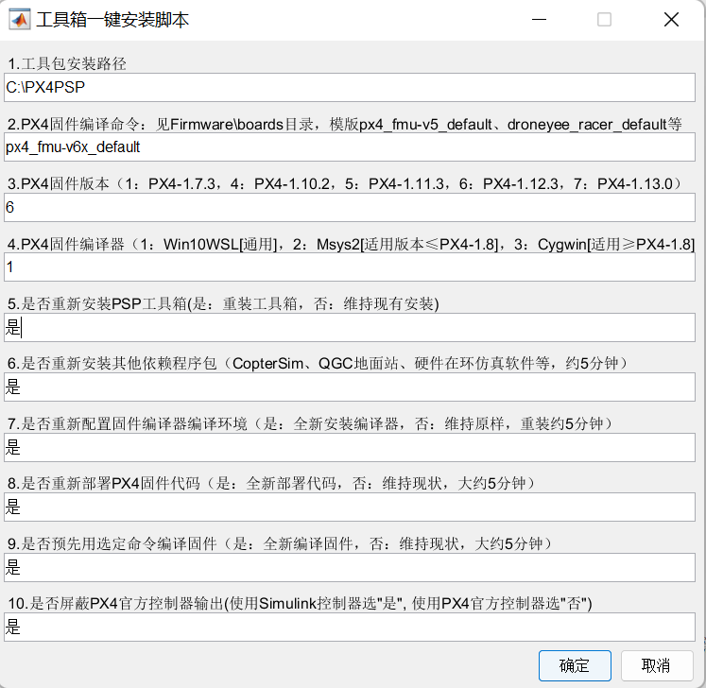

Figure 2 One-click installation script interface

**d）Installation Completion Result:** A folder named "RflyTools" will be generated on the desktop, as shown in Figure 4. In this folder, you can find most of the software shortcuts used in the development process of unmanned systems, forming a software ecosystem or toolchain for Sim2Real development in the unmanned systems domain. The main included software or tools are:

* **CopterSim: Core simulation software that runs multi-rotor motion dynamic models, together with other software, forming software/hardware-in-the-loop simulation.**
* **RflySim3D/RflySimUE5: Core 3D display software developed based on the Unreal Engine, providing highly realistic virtual reality display effects.**
* **HILRun/SILRun: One-click fast start scripts for software-in-the-loop/hardware-in-the-loop simulation. It can quickly launch all vision/cluster-related software and complete the necessary configurations.**
* **Python38Env: A Python environment that includes libraries like OpenCV.**
* **RflySimAPIs Example Folder: Contains all the examples and source code for this course, covering single/multi-vehicle control, cluster flight, visual control, etc.**
* **PPTs Courseware Folder: Contains all the courseware corresponding to this course.**
* **QGroundControl (QGC) Ground Station: Includes functions for configuring flight control parameters and controlling aircraft takeoff, landing, and route planning.**
* 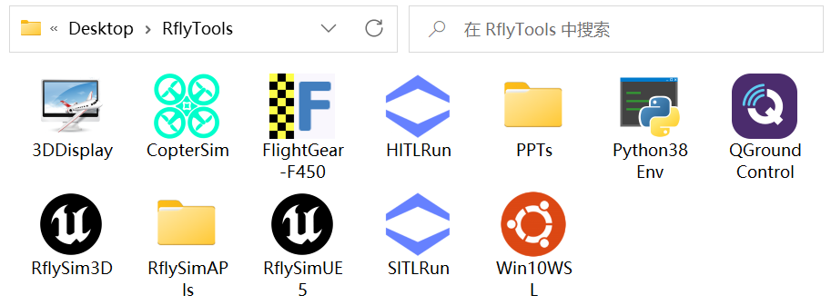**Win10WSL Compiler: Used for compiling firmware and software-in-the-loop simulation.**

Figure 3 Software desktop shortcut

As shown in Figure 5, after the one-click installation script completes its run, in the user-specified installation directory (e.g., C:\PX4PSP), you will find program files for all the software in the platform. These files correspond one-to-one with the desktop shortcuts shown in Figure 4. Among them, the "PPTs" courseware folder is the most crucial entry point for learning and using the platform, while "RflySimAPIs" contains all the experimental example programs of the platform. Note: During subsequent updates and upgrades, the contents of the "RflySimAPIs" example folder may be overwritten. Therefore, when conducting secondary development based on platform examples, it is advisable to copy the examples to another directory. In the installation directory, there is also a text file in the "RflySim***.txt" format, where the file name records the platform's version number and date, and it contains the platform's update log. With proper backup precautions, regularly download and update to the latest version of the platform to experience new features and address issues from older platform versions.

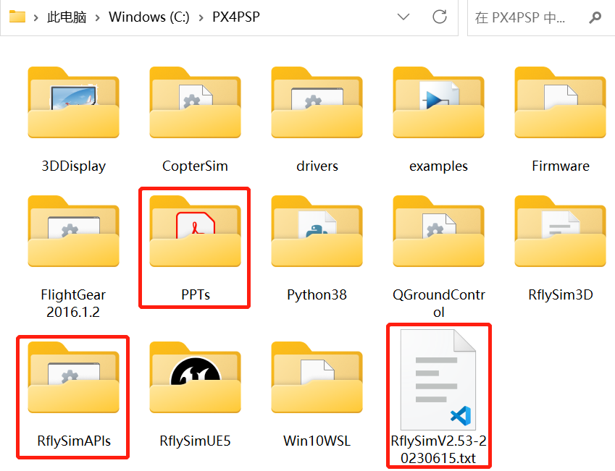

Figure 4 Preview of installation directory files



Figure 5 Confirmation method for successful installation of RflySim platform

**e）Confirmation of Successful Platform Installation:** As shown in Figure 4, double-click the SILRun one-click launch script shortcut in the RflyTools directory on the desktop. After entering the simulation quantity "1," you can initiate software-in-the-loop (SIL) simulation. As shown in Figure 5, enter the QGroundControl software and observe the aircraft entering the "Hold" mode. Click the "Takeoff" button. A confirmation slider will appear; drag it to the far right to commence automatic takeoff. If the aircraft can be seen taking off from the ground in the RflySim3D three-dimensional software, it indicates correct platform configuration, signifying a successful installation of the RflySim platform.

**f）Platform Uninstallation:** RflySim provides a one-click uninstallation feature. Users wishing to uninstall the platform can do so through two methods: automatic uninstallation and manual uninstallation. Automatic Uninstallation: Open the installation package directory with MATLAB, run the "uninstall.m" script to complete all uninstallation tasks. Manual Uninstallation: Refer to the comments in the uninstall.m file (or check the online documentation) for step-by-step uninstallation instructions. It is recommended to use the automatic uninstallation method.

**（2）RflySimSaT组件安装**

## Use the platform

### General development process introduction

As shown in Figure 6, the main development process of RflySim is divided into the following stages: Algorithm Development and Digital Simulation Verification, Simplified Model Joint Tuning, Software-in-the-loop Simulation, Hardware-in-the-loop Simulation, Indoor/Outdoor Flight Experiment, and Automated Testing and Evaluation.

In the Algorithm Development and Digital Simulation Verification stage, the primary tasks involve developing high-fidelity unmanned system models and simultaneously conducting the development and validation of low-level control algorithms to meet the initial requirements. Building on the previous stage's development, the Simplified Model Joint Tuning stage focuses on achieving top-level control of the unmanned system through external control, forming a closed-loop simulation for joint tuning.

Software-in-the-loop Simulation (SIL) refers to compiling and executing source code generated on the host machine as a separate process. By comparing the results of normal mode simulation with SIL simulation results, the numerical equivalence between the model and the generated code is tested. The entire SIL simulation stage on the RflySim platform can be carried out in the MATLAB/Python environment. Utilizing provided unmanned vehicle simulation models and routines, control algorithm design is performed in Simulink/Python. The model and controller are correctly connected to ensure input and output signals align with the actual unmanned system. For example, in the case of a multirotor unmanned aerial vehicle (UAV) system, the multirotor model sends sensor data or state estimation information (e.g., attitude angles, angular rates, position, and velocity) to the controller. The controller then sends PWM control commands back to the model for each motor, forming a closed-loop SIL simulation system. Users can observe control performance, modify or design controllers to meet desired performance requirements.

Hardware-in-the-loop Simulation (HIL) is a development and testing technology for real-time embedded systems. HIL simulation provides a dynamic system model that can simulate the real system environment, incorporating mathematical representations of relevant dynamic systems, and connecting them to the simulation system platform through the input and output of the embedded system. In the RflySim platform, Simulink UAV model parameters can be imported into CopterSim, and Simulink controller algorithms can be downloaded to the Pixhawk autopilot. USB physical signal lines replace virtual signal lines in Simulink. CopterSim sends sensor data (e.g., accelerometer, barometer, magnetometer, etc.) to the Pixhawk system via a USB data cable. The PX4 autopilot software in the Pixhawk system filters and estimates the received sensor data, sending the estimated state information to the controller through the internal uORB message bus. The controller then sends PWM control commands for each motor back to CopterSim, forming a closed-loop Hardware-in-the-loop simulation.

The Automated Testing and Evaluation stage involves designing efficient test cases based on different unmanned aerial vehicle types, existing airworthiness standards and requirements, along with the implementation details and key parameters of unmanned vehicle modeling. The design includes different test function points, standardized test processes, and the implementation of functions such as test case management, test environment configuration, automated testing and evaluation, and data management.



Figure 6 Development process

### Development preparation case (multi-rotor as an example)

This case serves as a preparatory case for developing fault injection, automated testing, and evaluation based on RflySimSaT. This section consists of four steps: Model Construction, Control Algorithm Construction, Fault Injection Preparatory Case Construction, and Automated Testing Platform Construction.

The purpose of Model Construction is to build the motion model of the unmanned vehicle provided by the user, enabling subsequent simulations for this model. We provide users with a comprehensive development template, ensuring the model's comprehensiveness and reliability.

For Control Algorithm Construction, the aim is to build custom control algorithms based on the user's testing requirements, including fault-tolerant control. We also provide a control routine template, allowing users to flash their algorithms onto their autopilots, facilitating subsequent safety testing and validation based on their specific vehicles and autopilots.

The goal of Fault Injection Preparatory Case Construction is to lay the foundation for automated fault injection and subsequent automated testing and evaluation. This step helps users understand the principles and processes of fault injection.

Lastly, Automated Testing Platform Construction aims to create a platform for automated and efficient safety testing and validation. Users can use their self-built models and autopilots with their control algorithms. Leveraging the common fault interfaces and test cases provided by the RflySimSaT platform, users can conduct fully automated and efficient safety testing and validation for their autopilots.

For detailed principles, online documentation, and rich development examples related to Model Construction, users can refer to the folders PX4PSP\RflySimAPIs\1.RflySimIntro\1.RflySim_SupportBook and PX4PSP\RflySimAPIs\4.RflySimModel. Similarly, for Control Algorithm Construction, the reference is PX4PSP\RflySimAPIs\5.RflySimFlyCtrl. Information about fault injection and the construction of the automated testing platform can be found in this document.

#### Model building

The model of an unmanned system generally falls into two categories: one is the dynamics model for the unmanned system, primarily used for the development of relevant control algorithms, and the other refers to the vehicle and three-dimensional scene model within the unmanned system, mainly employed for visualization and simulation. This case includes the development of both types of models.

As illustrated in Figure 7, the internal schematic diagram of the multi-rotor model shows that the overall inputs and outputs of the model are the PWM control signals for the motors and the state and sensor information of the multi-rotor. The motor model simulates the dynamic behavior of the motors; the force and torque module simulates the propeller thrust, aerodynamic forces on the airframe, gravity, and ground support forces, representing all external forces and torques. The rigid-body motion dynamic model calculates the kinematic states of the multi-rotor, including its velocity, position, and attitude. The environmental model, based on altitude, computes acceleration, air density, and other data. The output interface module packages the data into the required format. The sensor data output module simulates the output of sensor signals.

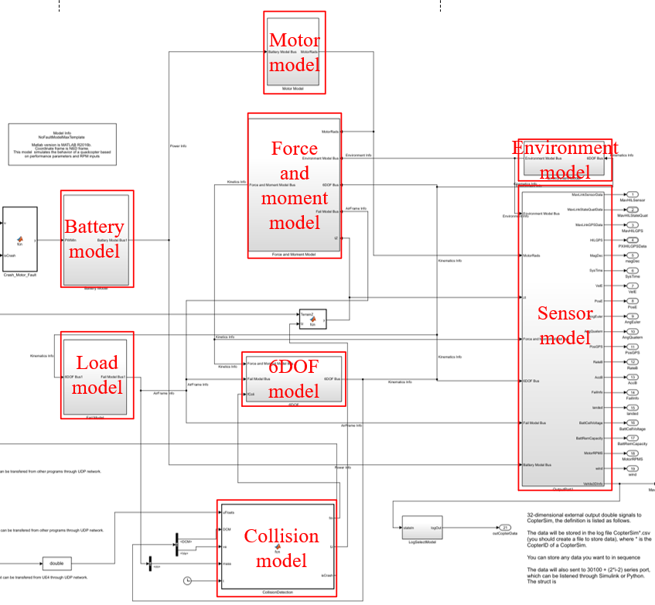

Figure 7 Internal schematic diagram of the multi-rotor model

In this case, the dynamic model of a quadcopter unmanned aerial vehicle (UAV) was built using MATLAB/Simulink, providing a profound understanding of the dynamic model of a quadcopter. This understanding is instrumental in grasping the motion characteristics of a quadcopter and facilitates the design of filters and controllers. For detailed experimental steps, refer to RflySimAPIs\5.RflySimFlyCtrl\1.BasicExps\e2-UavModeling\e2.1\Readme.pdf. RflySim has developed real-time visualization software, RflySim3D/RflySimUE5, based on the Unreal Engine real-time 3D rendering engine. This software supports the design and import of 3D scenes and aircraft models, with user-friendly operations. It allows the direct utilization of a vast library of 3D scenes and aircraft models from the UE4 scene library. Additionally, it supports the creation of 3D scenes and aircraft models using CAD software such as 3Ds Max, AutoCAD, and importing them into Unreal Engine (for detailed experimental steps, refer to RflySimAPIs\5.RflySimFlyCtrl\1.BasicExps\e2-UavModeling\e2.3\Readme.pdf).

#### Control algorithm construction

Flight control low-level algorithm development refers to the development of the underlying algorithms for the flight control system of unmanned aerial vehicles (UAVs). These algorithms are designed to achieve stable flight and precise control of UAVs. Flight control low-level algorithms encompass tasks such as acquiring and processing sensor data, establishing flight dynamics models, and designing and implementing controllers. Building on the previous section's development of the dynamic system model for a quadcopter, this section's case study will primarily use a PID controller to control the attitude of the UAV.

As illustrated in Figure 8, the internal schematic of the quadcopter controller consists of input interfaces for receiving signals from the remote controller and observing aircraft state signals. Remote control signal processing maps channel signals to desired attitude angles. The attitude controller calculates the desired output force and torque magnitude. Motor output allocation maps the control quantities of force and torque to throttle control quantities for the four motors. The output interface completes and maps the control quantities to motor PWM signals, achieving specified pitch and roll angles (for detailed experimental steps, refer to RflySimAPIs\5.RflySimFlyCtrl\1.BasicExps\e5-AttitudeCtrl\Readme.pdf).



Figure 8 Internal diagram of the controller module

#### Fault injection preparation case construction

##### Fault injection system architecture

The fault injection system platform framework is depicted in Figure 9. Firstly, it builds a high-precision model of the UAV and designs the overall fault model from the perspectives of the model, environment, and communication. It reserves external input fault interfaces to trigger corresponding faults. Secondly, it utilizes UE5 to construct a three-dimensional environment model for the UAV and embeds the overall fault model and three-dimensional environment model into a real-time UAV model simulator. Thirdly, it inserts a real autopilot into the simulation system, controls the overall fault model through control commands from the testing program, and conducts flight simulations.

The overall fault model adopts a distributed fault injection architecture. The model fault module, implemented through building Simulink fault models and standardized external trigger interfaces, can simulate faults in IMU, power units, wind, and other types of sensors. The communication fault module forwards all communication links through a unified interface, simulating faults such as delays and packet loss. The environment fault module, using a three-dimensional engine, generates obstacles or other objects with specified dimensions and sizes in real-time, simulating various safety testing scenarios in a realistic environment. This setup caters to security and reliability testing, including multi-agent cluster formation and intelligent decision-making, distributed networking and swarm cooperative exploration, and multi-scenario cooperative attack and defense.



Figure 9 Fault injection system platform architecture

##### Failure modeling solution

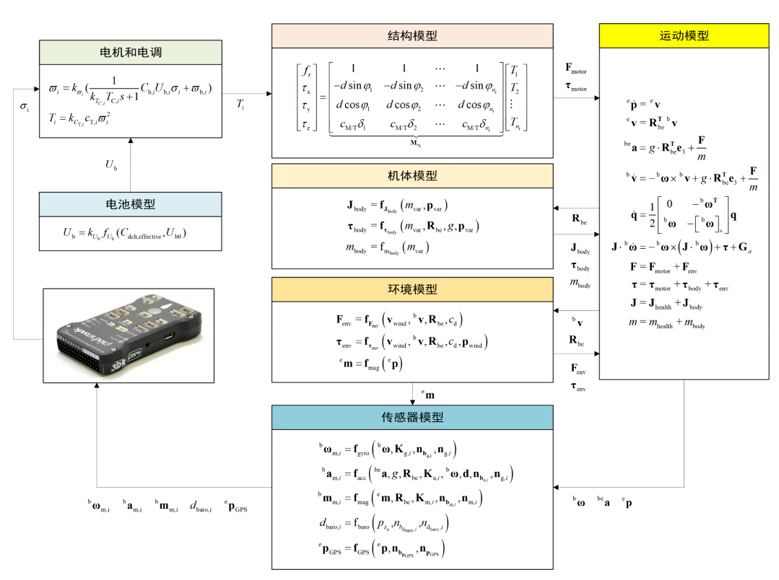

Figure 10 Complete machine failure model

**1）kinematic model**

The following set of formulas describe the basic motion model used inside the rigid body motion module in the figure above. All fault types shown in the above figure except for sensors are ultimately injected from the set of formulas below. details as follows:



where  and  respectively represent the position and velocity in the world coordinate system， is the speed in the body coordinate system， is the rotation matrix， is the weight of the multi-rotor aircraft, is the direction vector of the z-axis in the inertial coordinate system， is the total lift generated by all rotors of the multi-rotor aircraft， is the angular velocity of the body， is the acceleration due to gravity， is the body acceleration， is the moment produced by the propeller lift on the body axis.， represents the moment of inertia of the multi-rotor， represents gyroscopic moment.

1. Power system (motor, ESC, battery, propeller) faults will affect and ；
2. Environmental faults will affect ， and ；
3. Load faults will affect ， and ；
4. Sensor faults, unlike the above, primarily involve changes in scale factors and constant offsets, IMU data shocks, and variations in the variance of random walk noise.

**A．Power system faults can be described specifically as follows:**

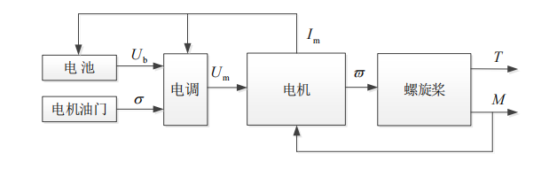

Figure 11 Dynamic system relationship

The power system model encompasses the entire power mechanism, consisting of the motor, motor controller, and rotor as a group, rather than just the brushless DC motor itself. The signal flow diagram of the power system is shown in the above figure, where the motor throttle is an input signal ranging from 0 to 1.

For the battery fault model, the battery voltage is obtained based on the effective discharge capacitance:



where  is the effective discharge capacitance, the function  is fitted based on the actual battery discharge data, and  is the battery fault coefficient.；

For the ESC fault model, its equivalent average voltage is given by:



where  is the throttle input received by the ESC， is the output voltage of the battery， is the ESC failure coefficient；

For the motor fault model, the dynamic process is simplified into a first-order inertia link, then the actual instantaneous speed of the motor is



where  is the motor response speed fault coefficient， is the motor execution efficiency failure coefficient， is the desired steady-state speed；

For the propeller failure model, the pulling force and moment are



where  is the tension coefficient， is the proportional coefficient of torque and pulling force， is the tension failure coefficient。

**B．Environmental faults include but are not limited to extreme weather conditions and the real-time generation of obstacles.**

For extreme weather, wind disturbance is one of the most common in extreme environments. Wind disturbances can be composed of several wind fields. Typically, they can be categorized as atmospheric turbulence, constant wind, gust wind, and wind shear. Therefore, wind disturbance faults include turbulence wind fault, constant wind fault, gust wind fault, and wind shear fault. This can be expressed as:



where  is the atmospheric turbulence wind field； is the normal wind field； is the cross-section wind； is gust of wind。Wind disturbance will cause changes in aircraft force and moment, which will lead to changes in the movement attitude of the entire aircraft. Among them, the force of wind disturbance can be described as:





where  is the air resistance coefficient of the body； is the speed of air relative to the body； is the attitude rotation matrix。The torque generated by air flow is expressed as:





where  is the position of the wind action point under the fuselage system, which acts near the center of gravity of the fuselage or near the load.

For the generation of real-time obstacles, an obstacle model is built through a 3D engine, and the model is called at a specific failure time to simulate specific task scenarios.

**C．Load failures include, but are not limited to, failure conditions caused by mass changes occurring on the machine body.**

The change in moment of inertia caused by mass deflection is





 is the changing moment of inertia, and the additional moment generated by mass deflection is



where  is the mass change that occurs in the body， is the position of  in the body coordinate system， is the attitude rotation matrix， is the magnitude of gravity acceleration。

**D．Sensor failures can be summarized as delays, interruptions, miscalibration, and noise in the data.**

Gyroscope faults can be summarized as: changes in scale factor, constant bias, data impulse, random walk noise, temperature drift, and data delay. Specifically it can be expressed as





where  is the true angular velocity of the body； is the calibrated angular rate； is Gaussian white noise； is the drift amount； is the scale factor change of the gyroscope; the subscript indicates the sensor serial number； is the gyroscope constant bias change； is the change of gyroscope white noise； is the change in impact coefficient of the gyroscope.

Accelerometer fault descriptions can be summarized as: changes in scale factors, constant bias, data impulses, and random walk noise. Specifically it can be expressed as：





where  is Gaussian white noise； is the real acceleration of the body； is the measured specific force after correction； is the drift amount； is the change of accelerometer scale factor；The subscript i represents the sensor serial number； is the acceleration due to gravity； is the true angular velocity of the body； is the lever arm vector.

Magnetometer fault description can be summarized as changes in scale factor, constant bias, and random walk noise. Specifically it can be expressed as：





where  is Gaussian white noise； is the magnetic induction intensity value of the first three axes of calibration； is the magnetic induction intensity value three weeks after calibration； is the change of magnetometer scale factor； is the drift amount；The subscript i represents the sensor serial number； is the attitude rotation matrix； is the change of magnetometer constant bias.

Barometer fault description can be summarized as scale factor, constant bias, and random walk noise changes. Specifically it can be expressed as：





where  is Gaussian white noise； is the change of barometer scale factor；The subscript i represents the sensor serial number； is the change in the constant bias of the barometer； is the drift amount； is the height of the body in geographical coordinates。

GPS fault description can be summarized as changes in scale factors and random walk noise. Specifically it can be expressed as：





where  is Gaussian white noise； is the change of scale factor；The subscript i represents the sensor serial number； represents the change in constant offset； is the drift amount； represents the true position signal； is the measured position signal.

##### Fault injection interface design

**（1）Fault Injection Protocol:**

To achieve efficient distributed model design and fault injection concepts, a standardized fault subscription and triggering mechanism is employed to assist in implementation: For model faults, standardized fault injection information, denoted as FaultIn, is published at the top-level model. Subsequently, various sub-modules subscribe to the FaultIn message and extract fault data specific to their respective modules. This enhances the efficiency of distributed development. Figure 12 illustrates the fault subscription for the motor module.



Figure 12 Example of fault publishing and subscription

Specifically, based on the model fault, the design of the standardized protocol is as follows:：

1. **Model faults are based on development. The fault injection interface for the model consists of an 8-dimensional integer array (inSILints) and a 20-dimensional floating-point array (inSILFloats). By publishing a globally scoped FaultIn data, it can be subscribed to by various sub-modules. inSILInts serves the purpose of fault verification and matching, specifying different fault types, while inSILFloats represents specific fault parameters to trigger specific fault levels under the respective fault types. Each inSILInts corresponds to two inSILFloats parameters;**
2. **Each fault corresponds to a unique FaultID value (int32 type, between -2147483648 and 2147483647), serving as a key mechanism；**
3. **All faults adopt the same structure and are input through inSILInts (8-dimensional Int32 type) and inSILFloats (20-dimensional float type), allowing for the injection of multiple faults simultaneously；**
4. **In the absence of fault injection, each fault module should not affect the normal output of the platform.**

【**Example 1**】：Given a motor fault with ID 123450 and four fault parameters corresponding to the efficiency of four motors of a quadrotor UAV, with injected fault parameters of 1, 0.8, 0.5, 1, what are the corresponding inSILints and inSILFloats?

**Solution:** For the motor fault with ID 123450, inSILints is set to [123450, 0, 0, 0, 0, 0, 0, 0], and the injected fault parameters of 1, 0.8, 0.5, 1 result in inSILFloats of [1, 0.8, 0.5, 1, 0, 0, 0, 0, 0, 0, 0, 0, 0, 0, 0, 0, 0, 0, 0, 0]. As each inSILInts corresponds to two inSILFloats parameters, for injecting 4 faults, inSILints is modified to [123450, 123450, 0, 0, 0, 0, 0, 0].

【**Example 2**】：Given a motor fault with ID 123450 and four fault parameters and an accelerometer fault with ID 123544 and one fault parameter for noise gain, injecting fault parameters of 1, 0.5, 0.2, 0.7 for the motor fault and a fault parameter of 5 for the accelerometer fault, what are the corresponding inSILints and inSILFloats?

**Solution:** Following the logic from Example 1, for the motor fault, inSILFloats is [1, 0.5, 0.2, 0.7, 0, 0, 0, 0, 0, 0, 0, 0, 0, 0, 0, 0, 0, 0, 0, 0], and inSILints is [123450, 123450, 0, 0, 0, 0, 0, 0]. For the accelerometer fault, inSILints is [123544, 0, 0, 0, 0, 0, 0, 0], and inSILFloats is [5, 0, 0, 0, 0, 0, 0, 0, 0, 0, 0, 0, 0, 0, 0, 0, 0, 0, 0, 0].

Combining the above, the overall inSILints is [123450, 123450, 123544, 0, 0, 0, 0, 0], and inSILFloats is [1, 0.5, 0.2, 0.7, 5, 0, 0, 0, 0, 0, 0, 0, 0, 0, 0, 0, 0, 0, 0, 0].

**（2）Standardized Control Sequence**

To achieve effective and efficient automated testing, a standardized control sequence protocol has been designed based on the standardized fault injection protocol. The protocol adopts a specific numeric string command format to regulate the control sequence, as illustrated in the diagram below:：



Figure 15: Schematic representation of the control sequence.

The testing script parses the control sequence from the database, thereby implementing the control logic for a test run. The test case database consists of 9 attributes, configured and managed by the db.json file. The structure of this JSON file is as follows:：

1）**"FAULT_CASE" is used for the configuration of test cases.** Specifically,

**"CaseID"**: Test case ID, a primary key that must be unique.

**"Subsystem"**: Testing subsystem.

**"Component"**: Testing component.

**"FaultID"**: Fault ID.

**"FaultType"**: Description of fault type.

**"FaultMode"**: Description of fault mode.

**"FaultParams"**: Fault parameters.

**"ControlSequence"**: Control sequence used for managing test commands for the UAV.

**"TestStatus"**: Test status.

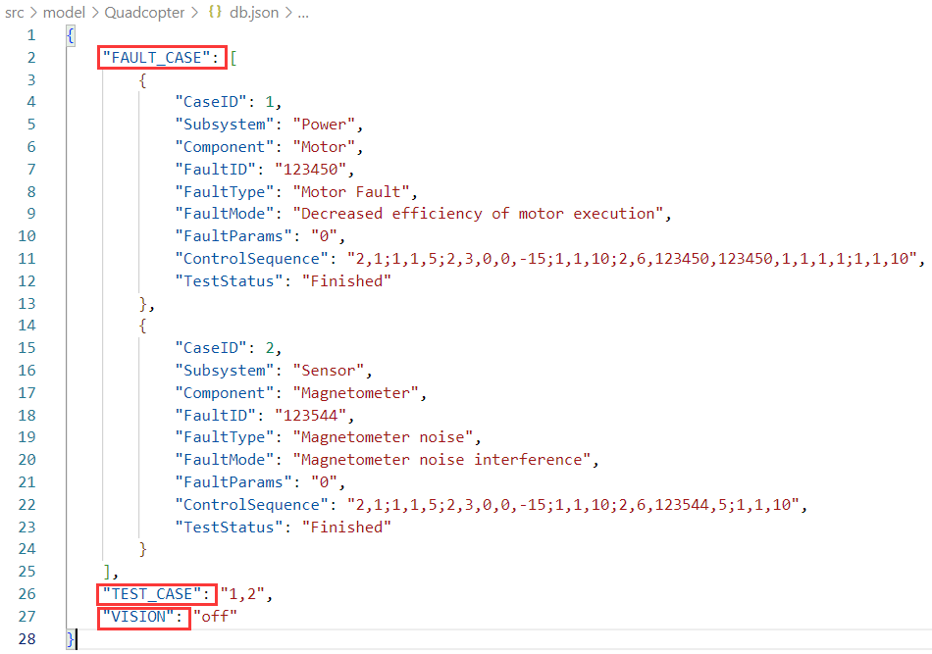

Figure 16: Schematic representation of the test case JSON file.

2）**"TEST_CASE" is used to manage the sequence of automated testing**. It accounts for both single-machine testing mode and multi-machine testing mode:

1. **Single Machine Mode**: In the diagram, "1,2" indicates testing for cases 1 and 2 (Note: In single-machine mode, each test case ends with a comma). To test all cases, change it to: "TEST_CASE": "All".
2. **Multi-Machine Mode**: If selecting multi-machine testing, each test ID ends with a semicolon (";"). For example: "1,2;1,3" means testing two rounds, where in the first round, UAV 1 tests case 1, and UAV 2 tests case 2. In the second round, UAV 1 tests case 1, and UAV 2 tests case 3. (Note: There should be a semicolon between test cases, or else it will not be detected and may lead to misinterpretation or errors).

3）**"VISION" serves as the vision interface.** Change it to "on" to enable the camera, and "off" to disable it.

**The "ControlSequence" consists of different commands. Each command ends with a semicolon (";"), and each command is composed of different strings. The first digit of each command represents a control class. The existing control class meanings are interpreted as follows:**

"1": Time class (including wait time and wait reset function).

"2": Control class (including unlock, lock, position control, velocity control, landing, fault injection functions).

The second digit of each command represents a specific function, and the subsequent digits represent the parameters of the corresponding function. Specifically, the existing functionalities for a quadcopter are interpreted as follows:

**"1": Time class:**

**"1": Wait time: Wait(times).**

**"2": Wait reset: WaitReset(Pos).**

**“2”：Control class:**

**"1": Unlock: Arm(void).**

**"2": Lock: DisArm(void).**

**"3": Position control: FlyPos(pos).**

**"4": Velocity control: FlyVel(vel).**

**"5": Landing: Land(void).**

**"6": Fault injection: FaultInject(param).**

【**Example 3**】：Parsing the control sequence "2,1;1,1,5;2,3,0,0,-20;1,1,15;2,6,123450,123450,0.6,0.8,1,1;1,1,10":

**Solution：** Unlock (2,1) -> Wait for 5s (1,1,5) -> Send position control to fly to [0,0,-20] (2,3,0,0,-20) -> Wait for 15s (1,1,15) -> Inject a fault (motor fault) with parameters [0.6,0.8,1,1] (2,6,123450,123450,0.6,0.8,1,1) -> Wait for 10s (1,1,10).

Note: Each command's first digit represents a class, the second digit represents the corresponding function, and subsequent digits represent the function's parameters. If there are no parameters, they do not need to be set.

#### Fault injection preparation case

##### Basic experiment: Master the use of fault injection maximum template and fault model public library

**Experiment 1: Usage of the Maximum Template Model (Using Multirotor as an Example)**

**Objective: Understand the use of the fault-free maximum template model, grasp the basic modules and relationships of the fault-free maximum template, and lay the foundation for subsequent fault modeling and injection.**

**Experimental Steps:**

1. The example routine is located in the directory src/examples/1.NoFaultModelMaxTemplate, with the following file structure:

|  |  |
| --- | --- |
| File | Meaning |
| Init.m | Model initialization file |
| MavLinkStruct.mat | Mavlink structure file data |
| MulticopterModelLib.slx | Multi-rotor model library file |
| NoFaultModelMaxTemplate.slx | Maximum fault-free template model |
| GenerateModelDLLFile.p | Dll model automatically generates files |
| NoFaultModelMaxTemplateHITL.bat | Maximum fault-free template model hardware-in-the-loop one-click script |
| NoFaultModelMaxTemplateSITL.bat | Maximum fault-free template model software-in-the-loop one-click script |

1. Open the file src/examples/1.NoFaultModelMaxTemplate/NoFaultModelMaxTemplate. Interested users can refer to the online documentation for further understanding of the modeling process and principles for multirotors and other vehicles. The learning documentation can be found in PX4PSP\RflySimAPIs\1.RflySimIntro\1.RflySim_SupportBook, and modeling routines can be found in PX4PSP\RflySimAPIs\4.RflySimModel directory.



1. Compile the model, automatically generate code, and create the MulticopterModel.zip package.



1. Right-click and run GenerateModelDLLFile.p to generate the dynamic link library file NoFaultModelMaxTemplate.dll.
2. Copy the generated NoFaultModelMaxTemplate.dll to the PX4PSP\CopterSim\external\model folder.
3. Open NoFaultModelMaxTemplateSITL.bat and NoFaultModelMaxTemplateHITL.bat files, change the "set DLLModel" to the file name, and run in administrator mode (this way, coptersim will load this vehicle model for simulation).

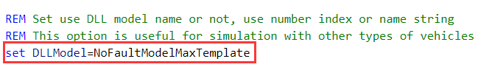

1. We can see

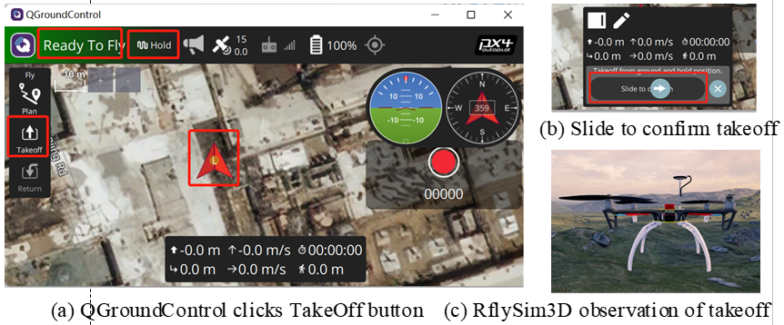

**Experiment 2: Utilizing the Fault Model Common Library (Using Multirotor as an Example)**

**Objective: Master the use of the fault library model's common library, understand the basic methods of creating and using a fault library, and lay the foundation for subsequent fault modeling and injection.**

**Experimental Steps:**

1. In the directory src/examples/1.NoFaultModelMaxTemplate, open the file src/examples/1.NoFaultModelMaxTemplate/MulticopterModelLib.slx as follows: In this case, the establishment and use of the GPS fault module are used as an example. Note that all fault modules need to be stored in the Simulink library file "MulticopterModelLib.slx" as the only module source. In the future, when multiple fault modules need to be used, they can be referenced from this module.

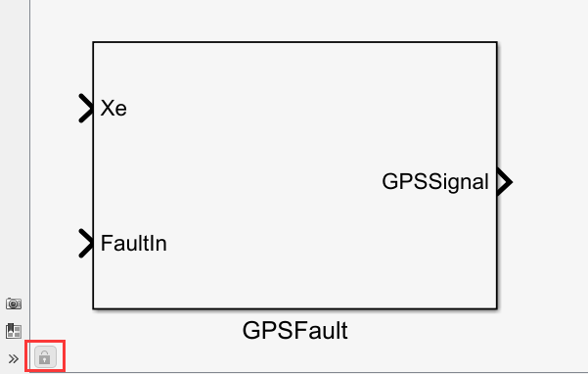

1. This module is locked by default and cannot be changed in this library file or any Simulink program that references this module. To make changes, the library file needs to be opened, and then click on the lock icon in the bottom left corner of the image.
2. Double-clicking on this module reveals two parameter input boxes, which need to be filled with two variables (can be scalars, vectors, or structures; here, a structure is used). The SensorFault field requires input of a structure used to store private parameters of this fault module (immutable during simulation), and the FaultParamAPI field stores a 32-dimensional parameter that can be sent from Python, serving as variable public parameters (mutable during simulation).

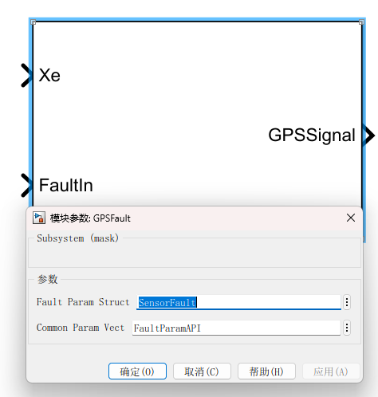

1. Open "Init.m" to see the code defining these two structures.

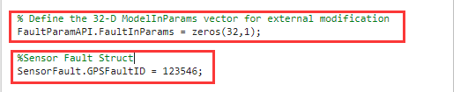

1. The above parameter input boxes are implemented through the module's Mask, as shown below. Right-clicking allows you to choose to edit the Mask. Note: If you are creating your own module, this should be creating a Mask.

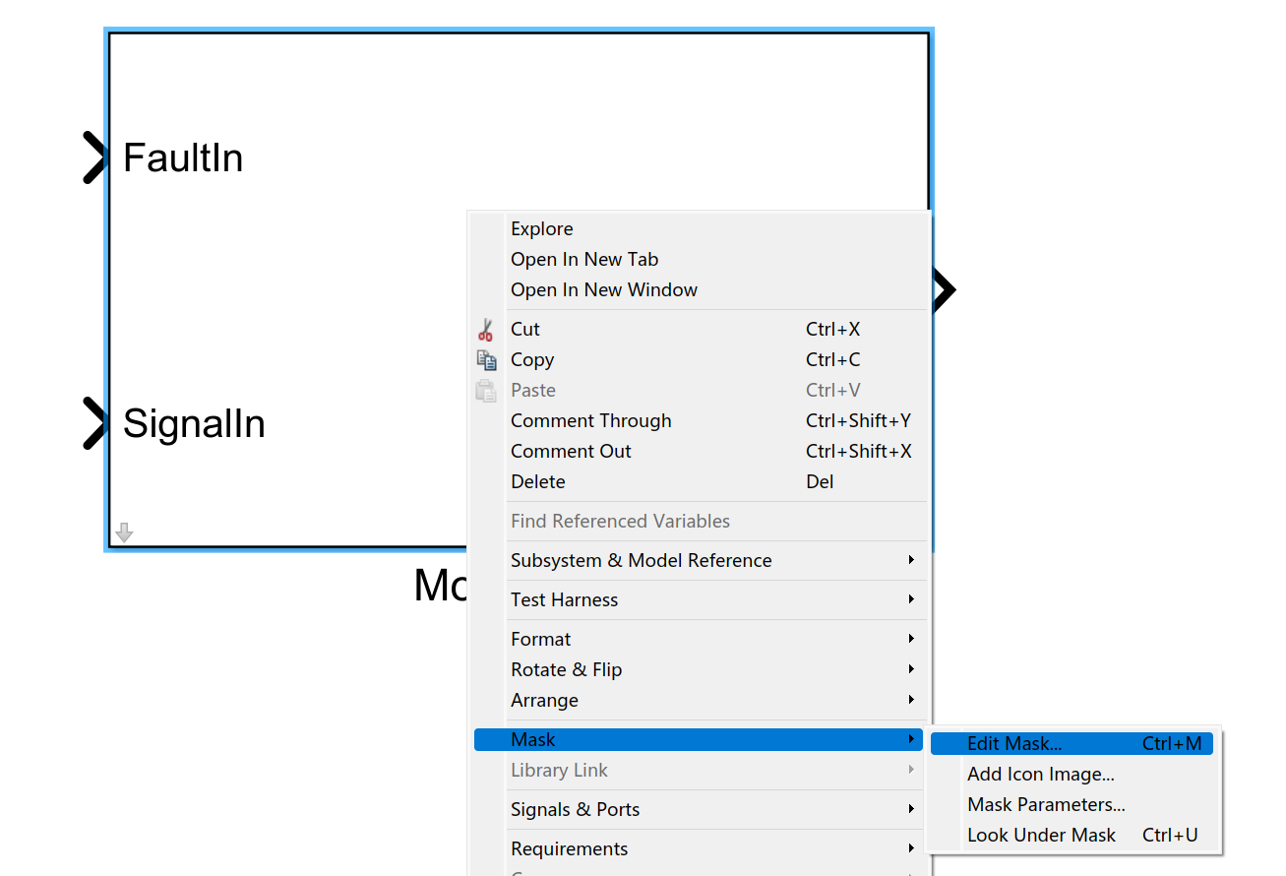

1. As shown below, two columns are created, and the inputs of these two columns are passed into the inner module using the aliases FaultParamStruct and ComParamVect.

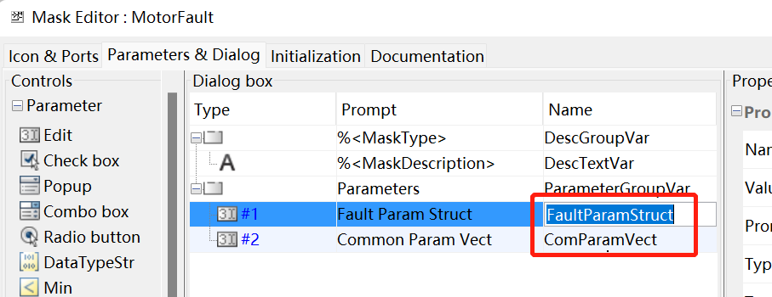

1. Click the down arrow in the bottom left corner to enter the module's interior.

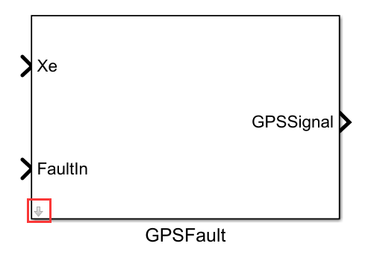

1. Utilize the two incoming variables mentioned above for internal programming. Note: In this example, we store the fault ID of the module in FaultParamStruct.FaultID (corresponding to the FaultID element of the incoming structure).

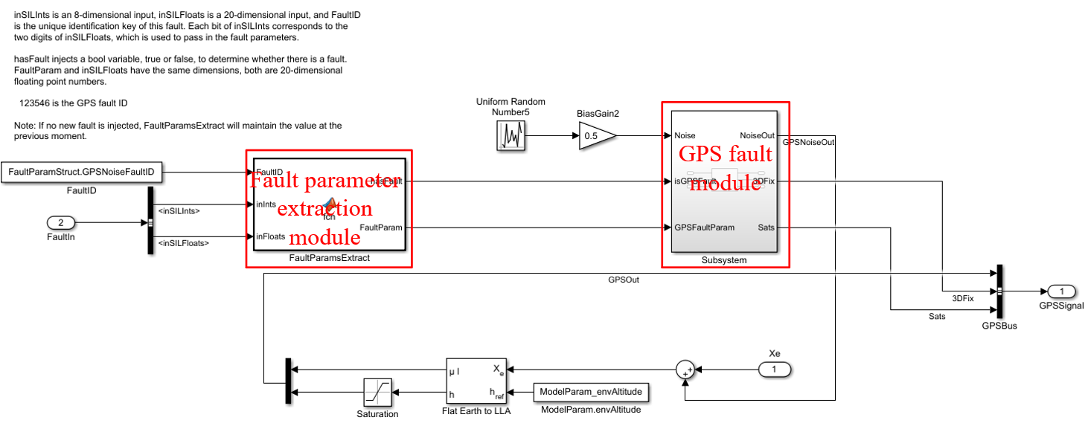

1. With this framework, private and public parameters can be passed into the fault module. Some parameters need to be declared in advance in init.m.

With this, Experiment 2 is complete. Users can build their own fault modules based on their interests and reference them where needed.

##### Advanced experiment: master the basic use of fault modeling and fault injection

**Experiment 1: Motor Fault Injection (Using Multirotor as an Example)**

**Objective: Master the modeling and injection process of motor fault injection.**

**Experimental Steps:**

1. In src\examples\3.MotorFaultModel\Init.m, design the motor fault ID and fault parameter structure. In the model file src\examples\3.MotorFaultModel\MulticopterModel.slx, subscribe to the fault message and publish it as a bus structure.



1. Write the motor fault module and design the fault algorithm.



1. Encapsulate the fault module and create a fault module library.

Select all the diagrams from step 2, right-click -> Create subsystem from the selected content. Once created, right-click on the subsystem -> Encapsulate -> Create Encapsulation. Save the created library as a ***Lib.slx file in the same path.



1. In MulticopterModel.slx, call the motor module from the fault library



1. Compile the model, automatically generate code, and create the MulticopterModel.zip package.



1. Right-click and run GenerateModelDLLFile.p to generate the dynamic link library MulticopterModel.dll.
2. Copy the generated MulticopterModel.dll to the PX4PSP\CopterSim\external\model folder.
3. Open src\examples\3.MotorFaultModel\MulticopterModelSITL.bat and wait for it to connect successfully.
4. In VSCode, open src\examples\3.MotorFaultModel\PythonSender and run FaultInjectAPI.py. Observe the effect of fault injection.



**Experiment 2: GPS Fault Injection (Using Multirotor as an Example)**

**Objective: Master the modeling and injection process of GPS fault injection.**

**Experimental Steps:**

1. In src\examples\2.GPSFaultModel\Init.m, design the GPS fault ID and fault parameter structure. In the model file src\examples\2.GPSFaultModel\MulticopterModel.slx, subscribe to the fault message and publish it as a bus structure.



1. Open the GPS module in src\examples\2.GPSFaultModel\MulticopterModel.slx and design the fault algorithm here, implementing fault subscription.



1. Compile the model, automatically generate code, and create the MulticopterModel.zip package.



1. Right-click and run GenerateModelDLLFile.p to generate the dynamic link library MulticopterModel.dll.
2. Copy the generated MulticopterModel.dll to the PX4PSP\CopterSim\external\model folder.
3. Open src\examples\2.GPSFaultModel\MulticopterModelSITL.bat and wait for it to connect successfully.
4. In VSCode, open src\examples\2.GPSFaultModel\PythonSender and run FaultInjectAPI.py. Observe the effect of fault injection.



**Experiment 3: Maximum Fault Injection Template Routine (Using Multirotor as an Example)**

**Objective: Master fault injection using the maximum template.**

**Experimental Steps:**

1） In src\examples\4.FullFaultModelTemplate\Init.m, design fault IDs and fault parameter structures. In the model file src\examples\4.FullFaultModelTemplate\MulticopterModel.slx, subscribe to fault messages and publish them as bus structures.

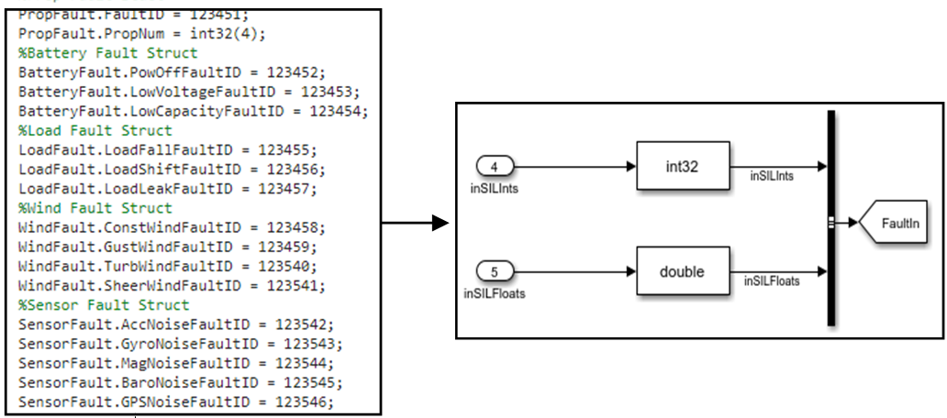

Existing fault IDs and parameters are as follows:

|  |  |  |
| --- | --- | --- |
| **FaultID** | **Fault Type** | **Fault Params** |
| **123450** | Motor Efficiency Fault | Efficiency ratio of Motor #1 to #x (0~1) |
| **123451** | Propeller Fault | Efficiency ratio of Propeller #1 to #x (0~1) |
| **123452** | Battery Failure Fault | None |
| **123453** | Low Voltage Fault | Voltage failure ratio (0~1) |
| **123454** | Low Battery Level Fault | Battery level failure ratio (0~1) |
| **123455** | Load Fault | Weight leakage ratio (0~1) |
| **123456** | Load Drift Fault | Weight leakage ratio + leakage factors x, y, z (0~1) |
| **123457** | Load Leak Fault | Weight leakage ratio + leakage factors (0~1) |
| **123458** | Constant Wind Fault | Wind speed on X, y, z axes |
| **123459** | Gust Wind Fault | Gust intensity + wind arrival time |
| **123540** | Turbulent Wind Fault | Turbulent wind intensity |
| **123541** | Tangential Wind Fault | Tangential wind intensity |
| **123542** | Accelerometer Noise Interference | Noise gain |
| **123543** | Gyroscope Noise Interference | Noise gain |
| **123544** | Magnetometer Noise Interference | Noise gain |
| **123545** | Barometer Noise Interference | Noise gain |
| **123546** | GPS Fault | Noise gain + 3D mode + number of satellites |

1. Move all created library models to the common library MulticopterModelLib.slx.

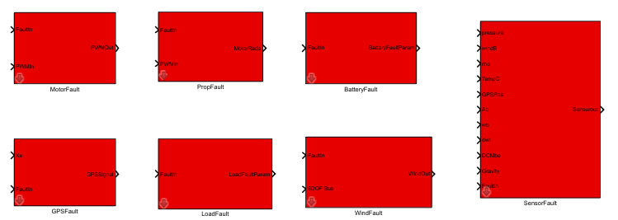

3）Open src\examples\4.FullFaultModelTemplate\MulticopterModel.slx (using GPS as an example) and design fault algorithms and implement fault subscriptions.



4） Compile the model, automatically generate code, and create the MulticopterModel.zip package.



5）Right-click and run GenerateModelDLLFile.p to generate the dynamic link library MulticopterModel.dll.

6）Copy the generated MulticopterModel.dll to the PX4PSP\CopterSim\external\model folder.

7）Open src\examples\4.FullFaultModelTemplate\MulticopterModelSITL.bat and wait for successful connection.

8）In VSCode, open src\examples\4.FullFaultModelTemplate\PythonSender and run FaultInjectAPI.py. Observe the effect of fault injection.



#### Automatic test platform construction:

Figure 17 shows the file structure of the automated testing platform. The "RflySimSDK" file is a dedicated proprietary library created for the RflySim platform, containing key interfaces and library files for control, communication, data, vision, etc. The "phm" branch library files are related to health and safety management, encompassing crucial interfaces for automated testing and evaluation. Key components include:

* AutoMAVDB：Common library for test case and data management, featuring automated operations on databases and files.
* AutoMAVCmd：File for parsing test sequences, mapping different test sequences to corresponding control commands to drive unmanned vehicle movement.
* AutoMAVCtrl：File for unmanned vehicle process management, covering test environment management, test task management, vehicle configuration, etc.
* PX4MavCtrlV4：File for communication management of unmanned vehicles, mapping key user commands to corresponding Mavlink messages, enabling communication initialization, control, and communication with other components.
* CameraCtrlApi and VisionCaptureApi: Files for visual management of unmanned vehicles, handling visual data configuration, management, and other operations.
* src/autotest: Main entry file for automated testing, allowing for one-click execution of automated tests for a specific vehicle by configuring its information in this file.
* src/openSHA：Common library files for health and safety assessment. The RflySimSaT platform provides an example of safety assessment based on the rate model reliability. Users can build their own safety and health assessment algorithms and perform online verification on this platform.
* src/model：This file contains model files and configuration information for different unmanned vehicles. The "db.json" folder in this directory can be configured to set up test cases for a specific model.
* data：Data management files for automated collection of test data from unmanned vehicles. The directory has four structures corresponding to four scenarios: 1) data/xITL/single/sInstance for single vehicle type and single instance; 2) data/xITL/single/mInstance for single vehicle type and multiple instances; 3) data/xITL/multi/sInstance for multiple vehicle types and single instance; 4) data/xITL/multi/mInstance for multiple vehicle types and multiple instances. Here, xITL represents both SITL and HITL simulation data.
* case：Database files. Due to the relatively complex nature of database file operations, each unmanned vehicle file in src/model provides a "db.json" file for configuring test cases. Test case configuration can also be done through a database visualization tool (in the tools folder).
* docs: Documentation folder providing a user manual for the platform, detailing principles, and usage methods.



Figure 17 Automatic test platform file structure

### Automated test case (quadcopter)

**Experiment 1: Automated Generation and Import of Test Cases**

**Objective: Understand the basic usage and configuration of test cases.**

**Experimental Steps:**

1. This experiment is located in the src\examples\5.AutoTest\1.DBExp folder, containing a Quadcopter.db file and an AutoCase.py file. Open the Quadcopter.db database file using tools\navicat_for_sqlite\navicat.exe.

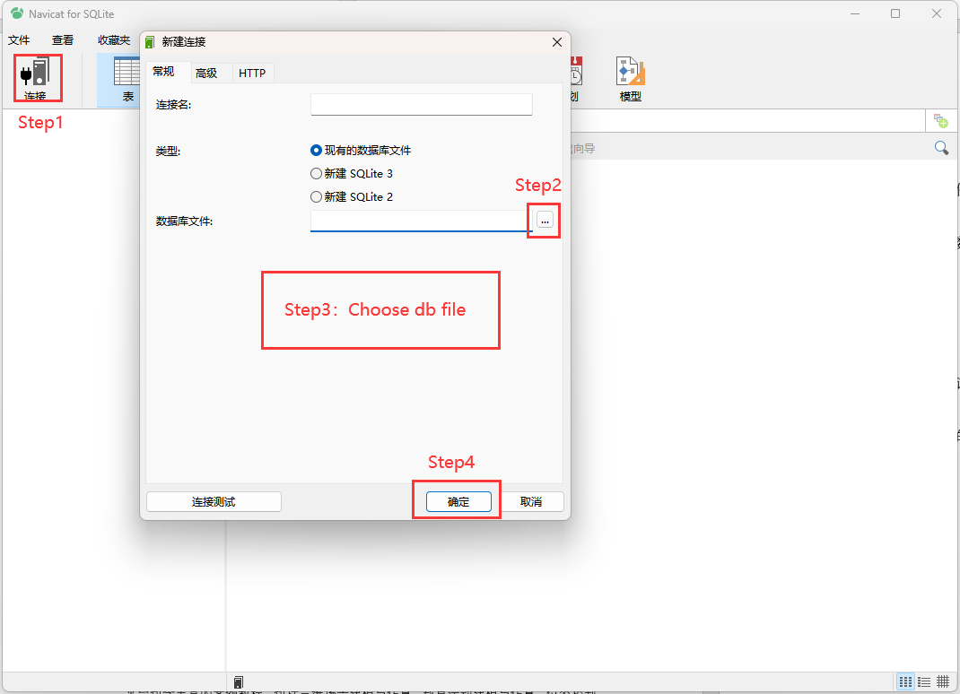

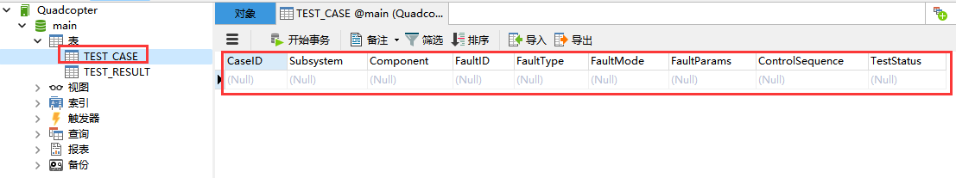

1. The database includes two tables, TEST_CASE and TEST_RESULT. TEST_CASE is the test case database file, and TEST_RESULT is the test result file.
2. Open the src\examples\5.AutoTest\1.DBExp folder and run AutoCase.py. You will observe that, based on your configuration, five JSON files are automatically generated, and the test information is uploaded to the database.

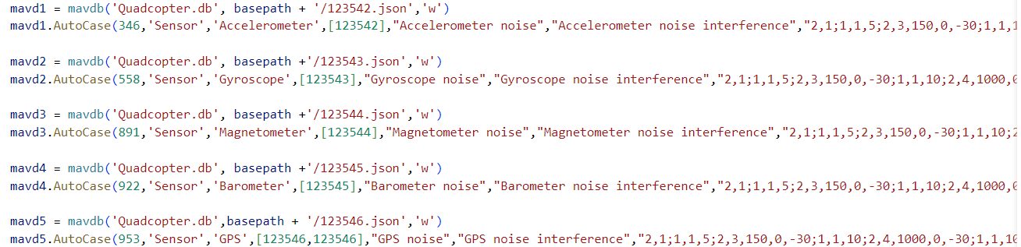

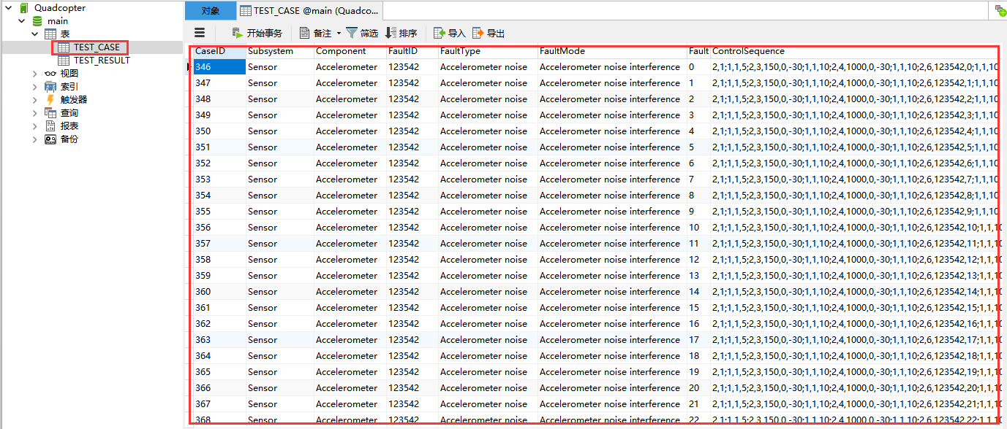

1. User Customization: Users can freely combine and generate test cases according to their needs and import them into the database.

**Experiment 2: Custom Control Sequence Configuration and Usage**

**Objective: Understand the basic usage and configuration of test cases.**

**Experimental Steps:**

1. This experiment is located in the src\examples\5.AutoTest\2.CmdExp folder, containing a db.json file and CmdCtrl.py file. CmdCtrl.py parses the control sequence from db.json and maps it to the vehicle's control commands.
2. Open the MulticopterModelSITL.bat script in src\examples\5.AutoTest\2.CmdExp in administrator mode and wait for all software to connect.
3. Execute the CmdCtrl.py script in src\examples\5.AutoTest\2.CmdExp. You will see that the program correctly parses the control sequence and completes the control process.

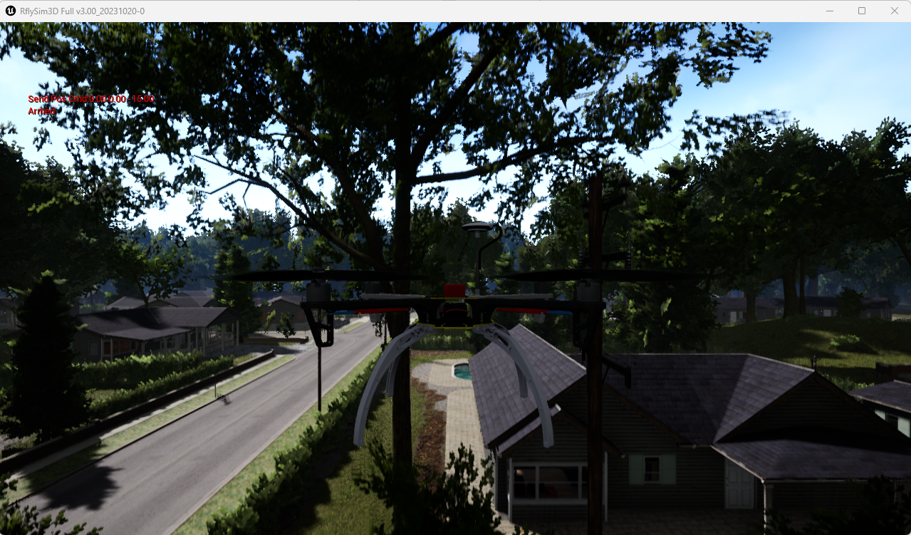

**Experiment 3: Automated Testing Platform Usage -> Single Machine Single Instance Automated Testing**

**Objective: Understand the basic structure and usage process of the automated testing platform for single-machine single-instance automated testing.**

**Experimental Steps:**

1. This experiment is located in the src\examples\5.AutoTest\3.SingFramSingleInsExp folder. Due to RflySimSaT's high integration, it contains only one main test entry file AutoTest.py and db.json. The rest of the files are placed in the RflySim platform's common library RflySimSDK.
2. Open the AutoTest.py file in src\examples\5.AutoTest\3.SingFramSingleInsExp. You will see key configuration parameters conf and mav. These parameters maintain different aircraft models and instance counts through lists. In this file, set it to single-machine mode.
3. Open db.json, and after the "TEST_CASE" keyword, you will see the test cases set to "1,2". The comma indicates single-machine testing mode, meaning aircraft 1 is automatically testing cases 1 and 2.
4. Copy the AutoTest.py and db.json files from src\examples\5.AutoTest\3.SingFramSingleInsExp to src\autotest and src\model\Quadcopter folders, respectively, replacing the original files.
5. Execute the AutoTest.py file in src\autotest. You will observe that this experiment automatically tests cases 1 and 2 for the quadcopter, and automatically records test data in the data\single\sInstance\Quadcopter folder under TestCase_1 and TestCase_2.
6. The experiment automatically records the test status, results, and other information, presenting visual results. You can view them in the beta\data folder in TestInfo.html and TestResult.html.

**Experiment 4: Automated Testing Platform Usage -> Single Machine Multiple Instance Automated Testing**

**Objective: Understand the basic structure and usage process of the automated testing platform for single-machine multiple-instance automated testing.**

**Experimental Steps:**

1. This experiment is located in the src\examples\5.AutoTest\4.SingFrameMultiInsExp folder. Due to RflySimSaT's high integration, it contains only one main test entry file AutoTest.py and db.json. The rest of the files are placed in the RflySim platform's common library RflySimSDK.
2. Open the AutoTest.py file in src\examples\5.AutoTest\4.SingFrameMultiInsExp. You will see key configuration parameters conf and mav. These parameters maintain different aircraft models and instance counts through lists. In this file, set it to single-machine multiple-instance mode. Set the instance count for conf to 2.
3. Open db.json, and after the "TEST_CASE" keyword, you will see the test cases set to "1;2". The semicolon indicates multiple-machine testing mode, meaning aircraft 1 tests case 1, and aircraft 2 tests case 2.
4. Copy the AutoTest.py and db.json files from src\examples\5.AutoTest\4.SingFrameMultiInsExp to src\autotest and src\model\Quadcopter folders, respectively, replacing the original files.
5. Execute the AutoTest.py file in src\autotest. You will observe that this experiment initializes two quadcopters and automatically tests case 1 for quadcopter 1 and case 2 for quadcopter 2. It also automatically records test data in the data\single\mInstance\Quadcopter folder under TestCase_1_2.

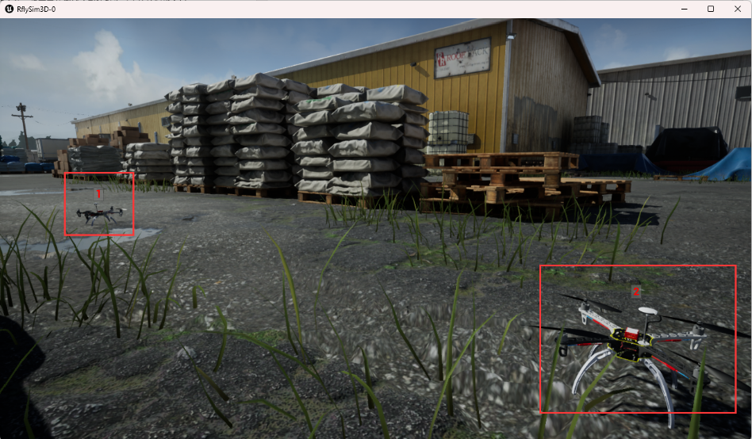

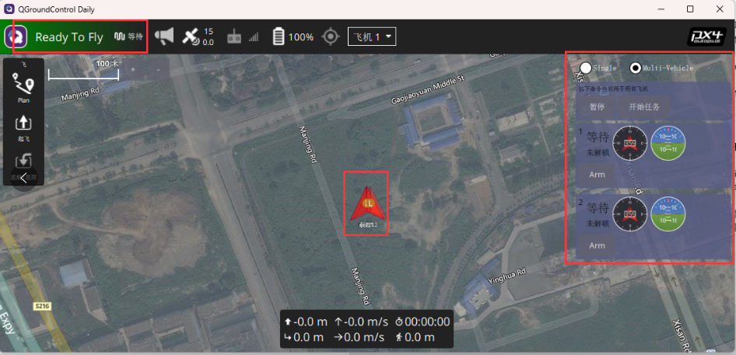

1. Automatically records the test status, test results and other information of the test case, and presents the visual results, which can be seen in TestInfo.html and TestResult.html under the beta\data folder.

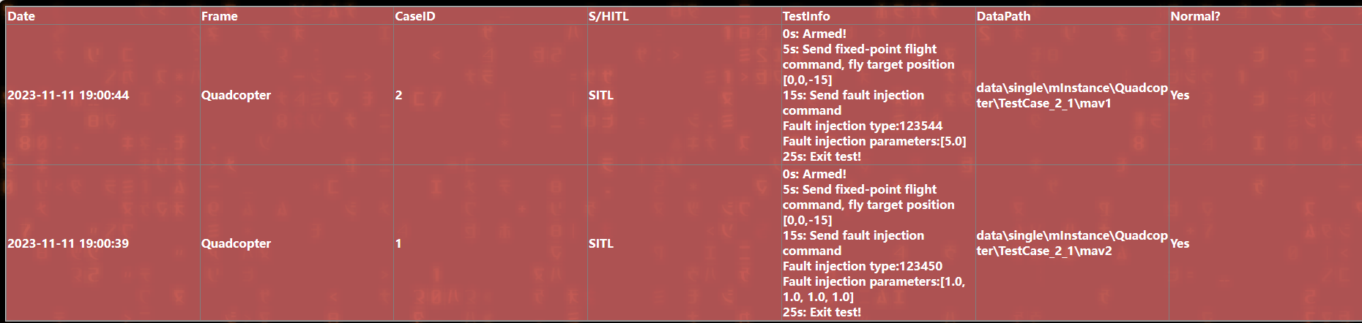

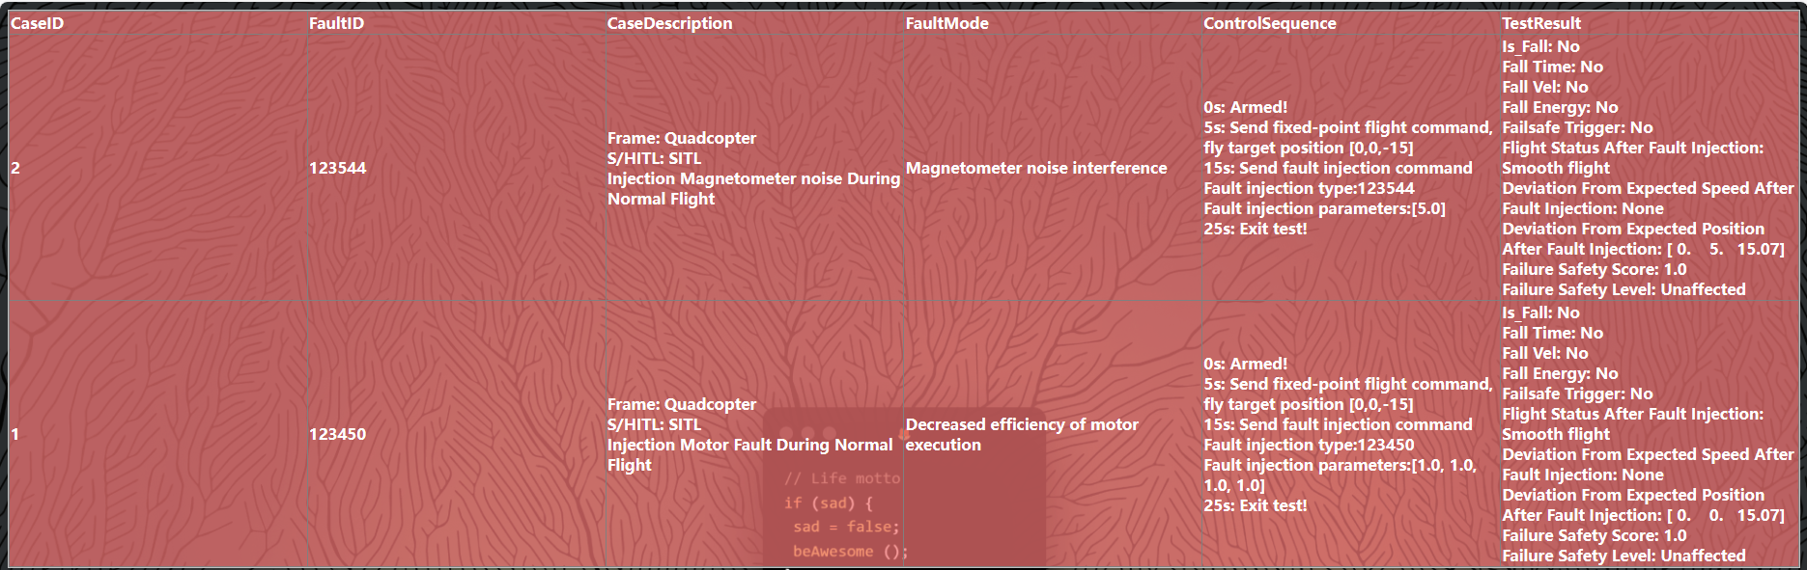

**Experiment 5: Automated Testing Platform Usage -> Multi-Model Single Instance Automated Testing**

**Objective: Understand the basic structure and usage process of the automated testing platform for multi-model single-instance automated testing.**

**Experimental Steps:**

1. This experiment is located in the src\examples\5.MultiFrameSingleInsExp folder. Due to RflySimSaT's high integration, it contains only one main test entry file AutoTest.py and db.json. The rest of the files are placed in the RflySim platform's common library RflySimSDK.
2. Open the AutoTest.py file in src\examples\5.AutoTest\5.MultiFrameSingleInsExp. You will see key configuration parameters conf and mav. These parameters maintain different aircraft models and instance counts through lists. In this file, set it to multi-model single-instance mode. Set the frame count for conf to 2, and instance count to 2.
3. Open db_Quadcopter.json and db_Fixedwing.json. After the "TEST_CASE" keyword, you will see the test cases set to "1,2". Since it is a multi-model single-instance mode, the instance count for different models is 1, so json files should be set to single-instance mode using a comma. This means testing case 1 for quadcopter and testing case 2 for fixed-wing. Note: When testing multiple models, the number of test cases for different models should be the same.
4. Copy the AutoTest.py, db_Quadcopter.json, and db_Fixedwing.json files from src\examples\5.AutoTest\5.MultiFrameSingleInsExp to src\autotest and src\model\Quadcopter, src\model\Fixedwing folders, respectively, replacing the original files. Rename db_Quadcopter.json and db_Fixedwing.json to db.json after copying.
5. Execute the AutoTest.py file in src\autotest. You will observe that this experiment initializes one quadcopter and one fixed-wing and automatically tests case 1 for the quadcopter and case 2 for the fixed-wing. It also automatically records test data in the data\multi\sInstance\TestCase_1_1\Quadcopter and data\multi\sInstance\TestCase_1_1\Fixedwing folders.
6. The experiment automatically records the test status, test results, and other information. Visual results can be viewed in TestInfo.html and TestResult.html under the beta\data folder.

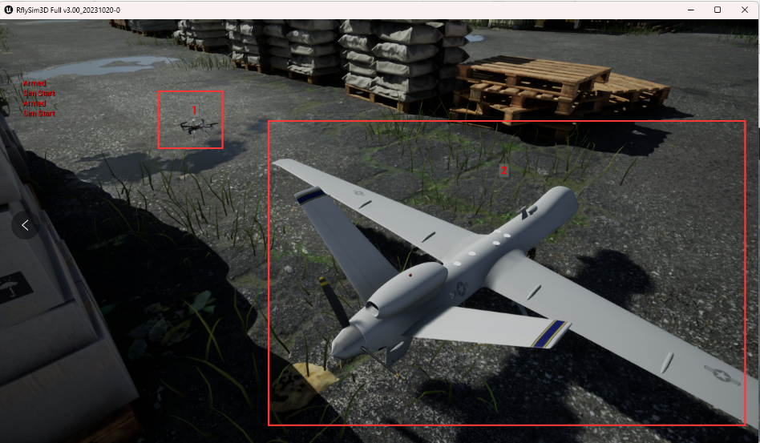

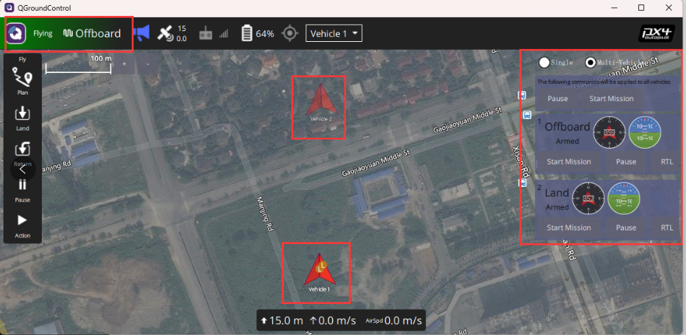

**Experiment 6: Automated Testing Platform Usage -> Multi-Model Multi-Instance Automated Testing**

**Objective: Understand the basic structure and usage process of the automated testing platform for multi-model multi-instance automated testing.**

**Experimental Steps:**

1. This experiment is located in the src\examples\6.MultiFrameMultiInsExp folder. Due to RflySimSaT's high integration, it contains only one main test entry file AutoTest.py and db.json. The rest of the files are placed in the RflySim platform's common library RflySimSDK.
2. Open the AutoTest.py file in src\examples\5.AutoTest\6.MultiFrameMultiInsExp. You will see key configuration parameters conf and mav. These parameters maintain different aircraft models and instance counts through lists. In this file, set it to multi-model multi-instance mode. Set the model count for conf to 2, and each model's instance count to 2.
3. Open db_Quadcopter.json and db_Fixedwing.json. After the "TEST_CASE" keyword, you will see the test cases set to "1;2". Since it is a multi-model multi-instance mode, the instance count for different models is greater than 1, so json files should be set to multi-model mode using a semicolon. This means testing cases 1 and 2 for 2 fixed-wing and 2 quadcopter instances. Note: When testing multiple models, the number of test cases for different models should be the same.
4. Copy the AutoTest.py, db_Quadcopter.json, and db_Fixedwing.json files from src\examples\5.AutoTest\6.MultiFrameMultiInsExp to src\autotest and src\model\Quadcopter, src\model\Fixedwing folders, respectively, replacing the original files. Rename db_Quadcopter.json and db_Fixedwing.json to db.json after copying.
5. Execute the AutoTest.py file in src\autotest. You will observe that this experiment initializes 2 quadcopters and 2 fixed-wings, and automatically tests cases 1 and 2 for the quadcopters and cases 1 and 2 for the fixed-wings. It also automatically records test data in the data\multi\mInstance\TestCase_1_1\Quadcopter and data\multi\sInstance\TestCase_1_1\Fixedwing folders.
6. The experiment automatically records the test status, test results, and other information. Visual results can be viewed in TestInfo.html and TestResult.html under the beta\data folder.

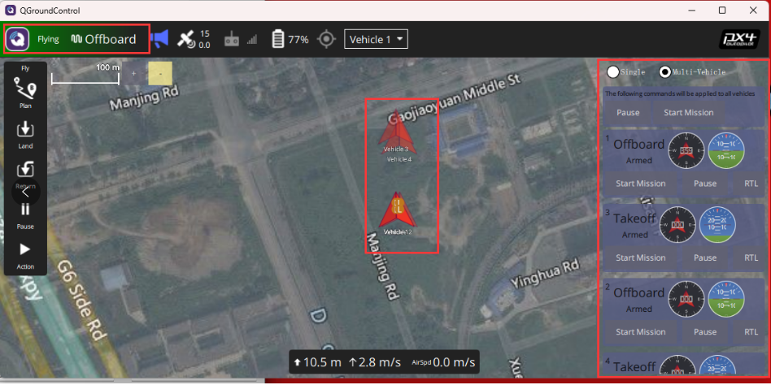

### Other cases

The platform includes a wealth of tutorial cases covering 3D scene modeling and simulation, vehicle motion modeling and simulation, pose control and filtering estimation, external control and trajectory planning, visual perception and obstacle avoidance decision-making, communication protocols, and cluster networking. All functionalities serve as test points for safety testing and evaluation. Some content has already been released, and we encourage you to stay tuned for ongoing updates on the RflySim platform.